**New Design**

**Single site**

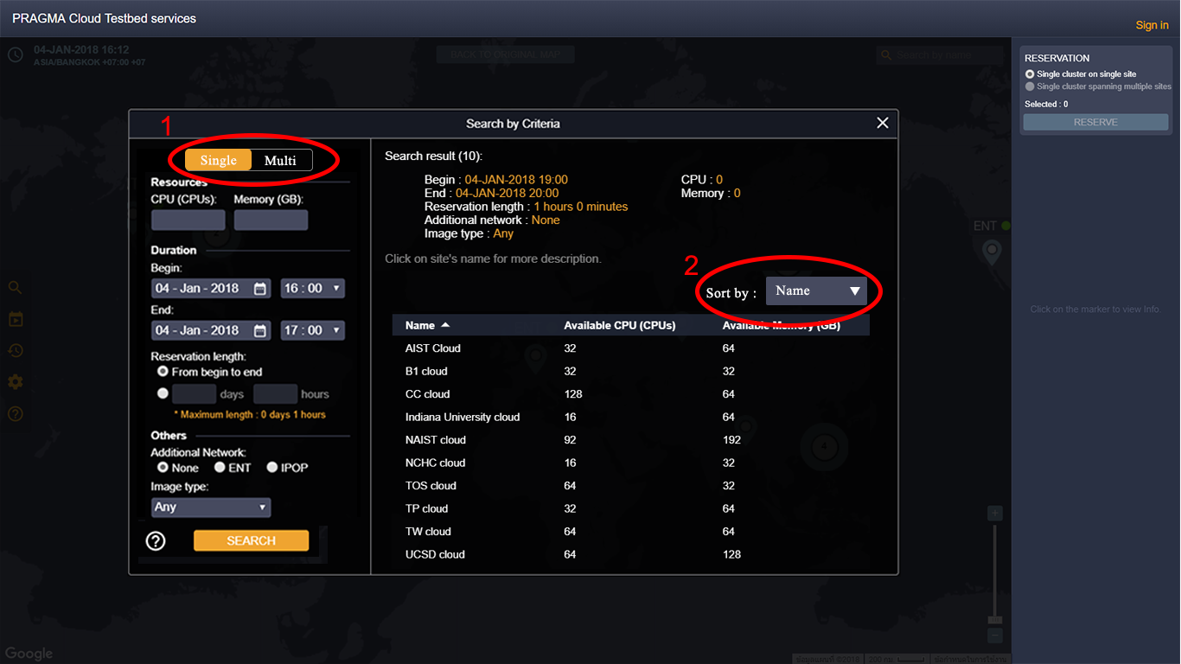

1. We add button for change mode between single and multi sites.
2. We add dropdown for sort the result by criteria.

**Multi sites**

**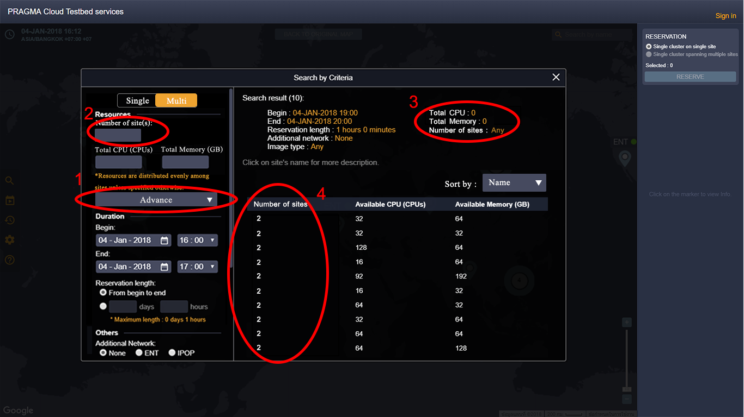  
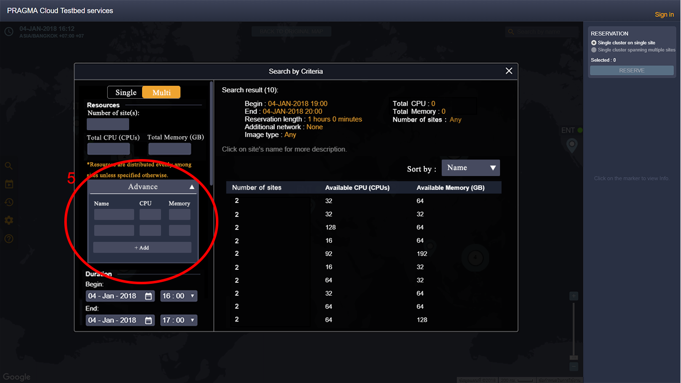**

1. This is advance of multi sites when you click it will expand and become to number 5 in third image.
2. It is a input for user add number of sites. It can input only number. If it blank it will search only the most less number of site.
3. They are information of multi-sites for user re-check search result.
4. They are the information for number of sites.
5. It is a input for users config multi-site by themself. Default is 2 sites.

**Question**

1. How many minimum resource of multi-sites?  
   Ans. It isn’t important because users have spec of resource for reservation before. We don’t set default value.
2. Must the advance search of multi-sites be name of site or continent?  
   Ans. Name
3. Will The detail of site have only one or more than one CPU speed?  
   Ans. Only one CPU speed.
4. Will The result of multi-sites show all case or only case that less site?  
   Ans. Only less site.
5. Will we support in case indivisible resource?  
   Ans. We just support only memory that can divisible but CPU is not.
6. What are data that users use for sort result?   
   Ans. Name, Distance (Between user and that site), CPU, Memory and CPU speed.
7. If we can’t find any group of multi-site that match with criteria how can we do?  
   Ans. If users specific site we will suggest same site but other time or other site but same time. If users don’t specific we will suggest other time.

**Example**

Site UF(America) AIST(Asia) UF(America) TU

case1

Share Equivalent style. However, if you have enough resources, you will not be able to complete the first case.

Search result for multi-site resources :

Total CPU: 16 Total Memory: 64GB

Begin: 5 Jan 2018 Time:20:00

End: 6 jan 2018 Time:03:00

Reservation length : 7 hour

Additional network : any

Image type : any

Fri,5-6 Jan 20:00-03:00 7hour ENT CentOS

Site1 : UF CPU: 8 Memory :32GB

Site2 :AIST CPU:8 Memory: 32GB

Fri,5-6 Jan 20:00-03:00 7hour ENT,IPOP CentOS,OpenStack

Site 1: UF CPU:8 Memory :32GB

Site 2: UCSD CPU:8 Memory :32GB

Fri,5-6 Jan 20:00-03:00 7hour ENT CentOS

Site 1: UF CPU:4 Memory :16GB

Site 2: AIST CPU:4 Memory :16GB

Site 3: UCSD CPU:4 Memory :16GB

Site 4: TU CPU:4 Memory :16GB

case 2

Site 1 share smallest resource to Site 2, only to use the Muti-Site system

ratio of CPU to memory is 1: 2.This case is only used for The user wants to use the Muti-site system regardless of the size of the resource.

Search result for multi-site resources :

Total CPU: 16 Total Memory: 64GB

Begin: 5 Jan 2018 Time:20:00

End: 6 jan 2018 Time:03:00

Reservation length: 7 hour

Additional network: any

Image type: any

Fri,5-6 Jan 20:00-03:00 7hour ENT CentOS

Site1 : UF CPU: 15 Memory :62GB

Site2 :AIST CPU:1 Memory: 2GB

Fri,5-6 Jan 20:00-03:00 7hour ENT CentOS

Site1 : UF CPU: 1 Memory :2GB

Site2 :AIST CPU:15 Memory: 62GB

Fri,5-6 Jan 20:00-03:00 7hour ENT CentOS

Site 1: UF CPU:7 CPUs Memory :30GB

Site 2: AIST CPU:7 CPUs Memory :30GB

Site 3: UCSD CPU:2 CPUs Memory :4GB

case 3

Search engines are not able to find a site with the features they are looking for, so trying to find sites that are similar to what users are looking for may be used by those users.

Search result for multi-site resources :

Total CPU: 16 Total Memory: 64GB

Begin: 5 Jan 2018 Time:20:00

End: 6 jan 2018 Time:03:00

Reservation length: 7 hour

Additional network: any

Image type: any

Fri,5-6 Jan 21:00-04:00 7hour ENT CentOS

Site1 : UF CPU: 8 Memory :32GB

Site2 :AIST CPU:8 Memory: 32GB

Fri,5-6 Jan 20:00-03:00 7hour IPOP CentOS,OpenStack

Site 1: UF CPU:8 CPUs Memory :32GB

Site 2: UCSD CPU:8 CPUs Memory :32GB

Fri,6-7 Jan 20:00-03:00 7hour ENT CentOS

Site 1: UF CPU:6 CPUs Memory :28GB

Site 2: AIST CPU:6 CPUs Memory :28GB

Site 3: TU CPU:4 CPUs Memory :8GB